Shell Script:

1. Write a shell script to reverse a number.

echo "Enter a number :"

read a

rev = 0

while [ $a -gt 0 ]

do

$dig=$(($a%10))

$a=$(($a/10))

$rev=$(($rev*10 + $dig))

done

echo "$rev"

2 Write a shell script to perform mathematical operations using menu. (+_*/ **)

|  |
| --- |
| #! /bin/bash  clear  sum=0  i="y"  echo -n "Enter the first no : "  read n1  echo -n "Enter the second no : "  read n2  while [ $i = "y" ]  do  echo "1.Addition"  echo "2.Subtraction"  echo "3.Multiplication"  echo "4.Division"  echo -n "Enter your Choice : "  read ch  case $ch in  1)sum=$(($n1 + $n2))  echo "Sum =$sum";;  2)sum=$(($n1 - $n2))  echo "Sub ="$sum;;  3)sum=$(($n1 * $n2))  echo "Multi ="$sum;;  4)sum=$(($n1 / $n2))  echo "Div ="$sum;;  *)echo "Invald Choice";;  esac  echo "Do you want to Continue ?"  read i  if [ $i != "y" ]  then  exit  fi  done |

3. Write a shell script to test the file is a executable file or not.

4. Write a shell script to find smallest of three numbers that are read from keyboard

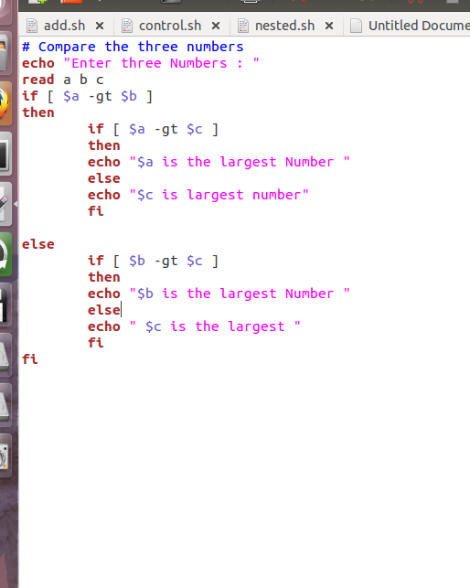

5. Write a shell script to display list of all files in the current directory to which you have read write

and execute permissions.

6. Write a shell script to check the entered no is palindrome or not

7. Write a shell script to remove only empty files from current

8. Linear Search

9. Binary Search

10. Bubble Sort

11. Selection sort

**Program:-**

#!/bin/bash  
echo "enter the number"  
read n  
echo "enter number in an array"  
for((i=0;i<n;i++))  
do  
read arr[$i]  
done  
#logic for selection sort  
for((i=0;i<n-1;i++))  
do  
small=${arr[$i]}  
index=$i  
for((j=i+1;j<n;j++))  
do  
if((arr[j]<small))  
then  
small=${arr[$j]}  
index=$j  
fi  
done  
temp=${arr[$i]}  
arr[$i]=${arr[$index]}  
arr[$index]=$temp  
done  
#printing sorted array  
echo "printing sorted array"  
for((i=0;i<n;i++))  
do  
echo ${arr[$i]}  
done

12. Arithmetic operations using functions

Program:-

a=10

b=20

Add(){

val=`expr $a + $b`

echo "a + b : $val"

}

Diff(){

val=`expr $a - $b`

echo "a - b : $val"

}

Mul(){

val=`expr $a \* $b`

echo "a * b : $val"

}

Div(){

val=`expr $b / $a`

echo "b / a : $val"

}

Mod(){

val=`expr $b % $a`

echo "b % a : $val"

}

Add

Diff

Mul

Div

Mod

13. Write a shell script that accepts two file names from the command line, copies the first to second file and display the second file.

Program:-

Src = $1

targ= $2

if [ ! -f $src ]

then

echo "File $src does not exists"

exit 1

elif [ ! -f $targ ]

then

echo "File $targ does not exist"

exit 2

fi

# copy file

cp $src $targ

# store exit status of above cp command. It is use to

# determine if shell command operations is successful or not

status=$?

if [ $status -eq 0 ]

then

echo 'File copied successfully'

else

echo 'Problem copying file'

fi

14.

Write a shell script that assigns execute permission to a file.8 Write a shell script that accepts one file

and directory name and move that file to the directory and show recursive listing and long listing.

15. Write a shell script to give the result of student. Take marks of the five subjects, student name,

roll no and percentage and show a message whether a student gets division as per the following

rules:70% &lt;-&gt; distinction60%-&gt;1

16. Write a shell script to find out the gross salary and Net_salary of an employee .

Grosssal=Basic_sal+DA+ HRA

Basic_sal DA% HRA%

&gt;=20000 60 30

&gt;=10000 and &lt;20000 50 25

Else 40 20

17) Menu driven program for following cases

1. To check entered number is Even odd

2. To check entered number is palindrome.

3. To check entered number is Armstrong.

DONE IN EXP

18) Program to implement calculator using command line argument.

19) Program to display Fibonacci series and n th term of Fibonacci series

using function .

**Program:-**

#!/bin/bash  
echo "How many numbers do you want of Fibonacci series ?"   
read total   
x=0   
y=1   
i=2   
echo "Fibonacci Series up to $total terms :: "   
echo "$x"   
echo "$y"   
while [ $i -lt $total ]   
do   
i=`expr $i + 1 `   
z=`expr $x + $y `   
echo "$z"   
x=$y   
y=$z   
Done

20) To check whether given number is prime or not using function.

|  |
| --- |
| is_prime () {  declare -a REMAINDER_S=()  let ARG_1=$1-1  for N in $(seq 2 $ARG_1)  do  let REMINDER=$1%$N  if [ $REMINDER == 0 ]  then  REMINDER_S=("${REMINDER_S[@]}" $REMINDER)  return 1  fi   done   if [ ${#REMINDER_S[@]} == 0 ]  then  return 0  fi } |

21) Write shell script to display list of users currently logged-in,

22) Display top 10 processes in descending order of CPU utilization and display processes

with highest memory usage.

23) Shell script program to check whether given file is a directory or not

24)Shell script program to count number of files in a Directory

25)Shell script program to copy contents of one file to another